Hierarchical structure of IFB299Project

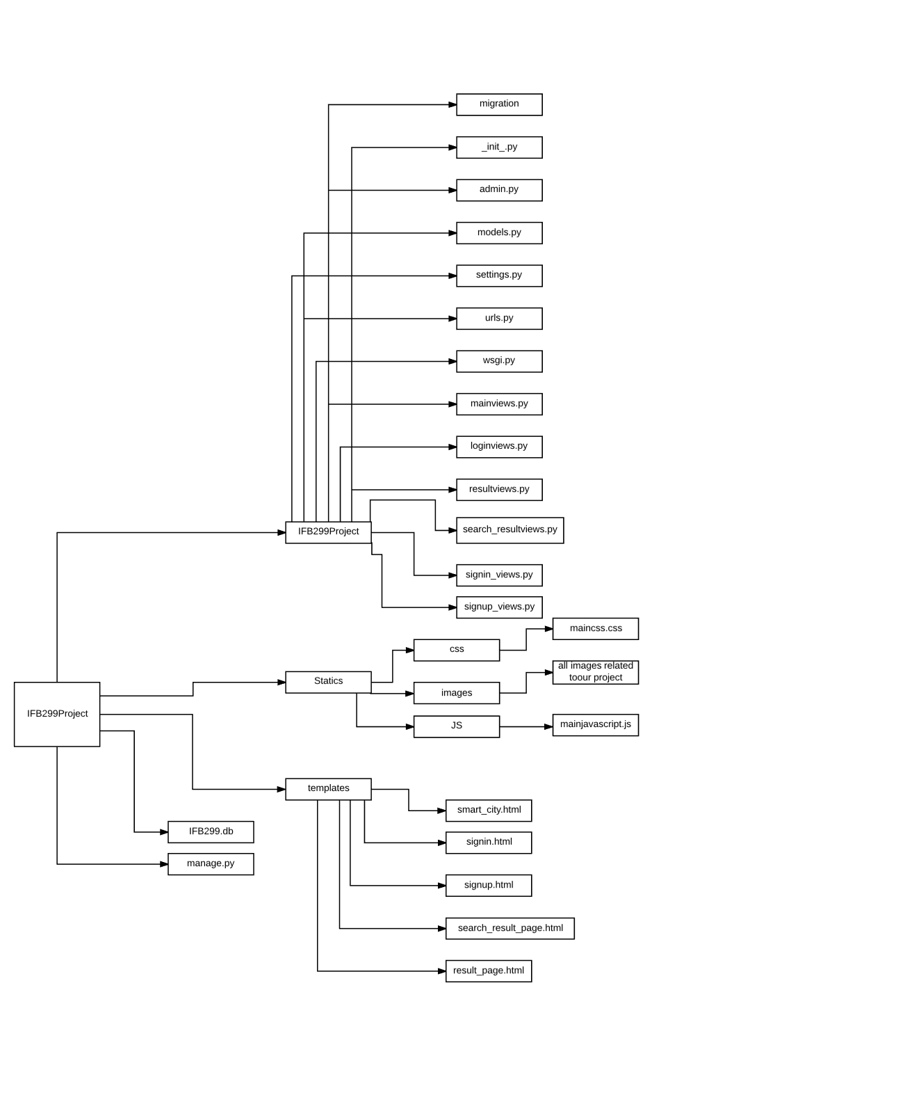hierarchical structure of the project shows all the files and folder of the project.